

**Name: Usama Yousuf Khan**

**Sec: 7A**

**Roll no 20P-0646**

**Course: Block-Chain**

**Project**

**Purchase Contract**

**Submitted to Bahar Ali**

**Screen Shots**

**Before Compilation**

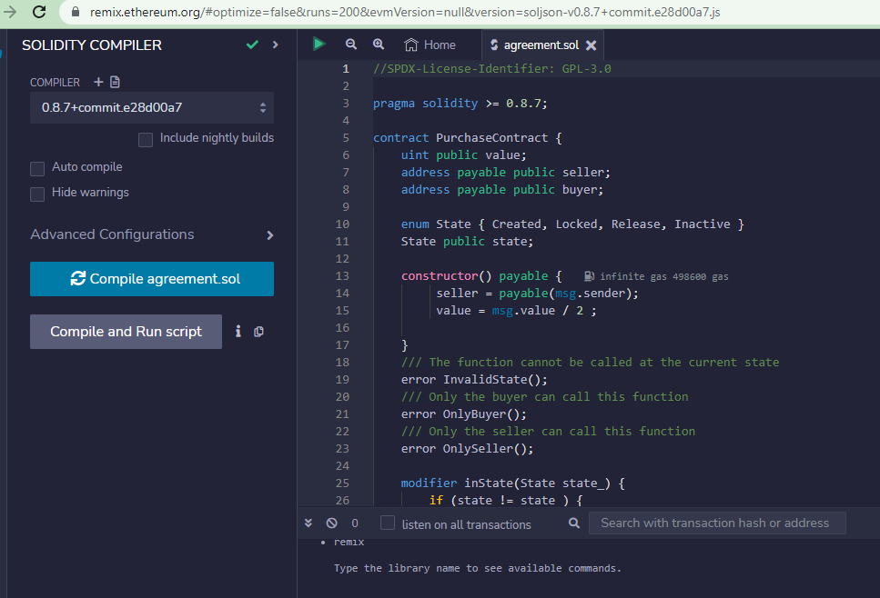

**After Compilation:**

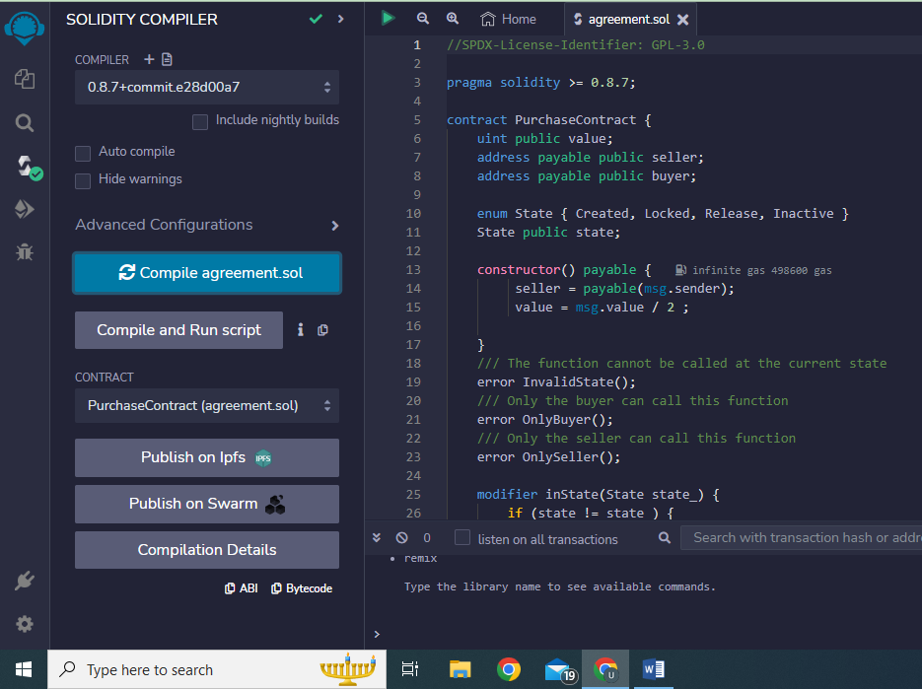

**Before Deployement**

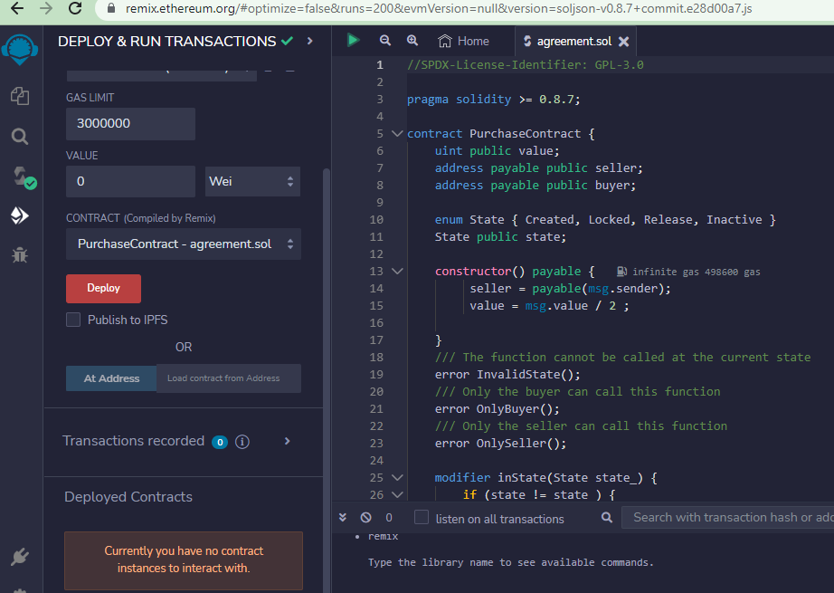

**After Deployment**

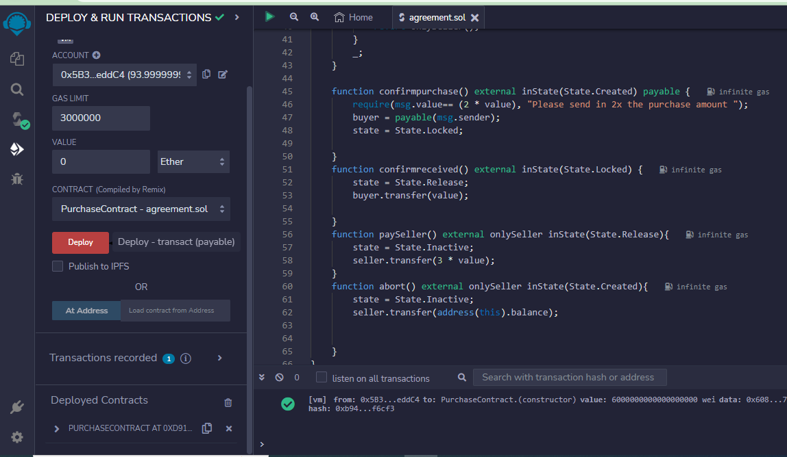

**Deployed Contract**

